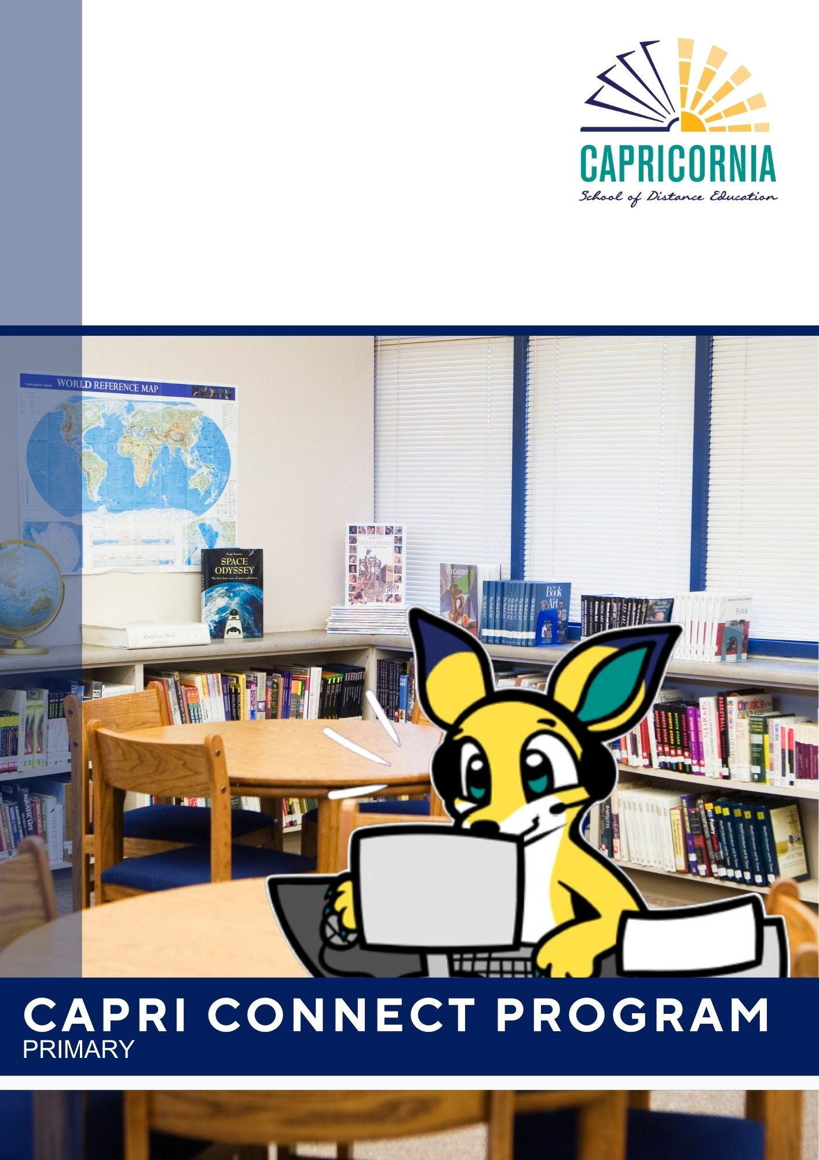

Table of Contents

Primary Capri-Connect Online Sessions 2025 2

Welcome to Capri-Connect 2

What is Capri-Connect? 2

Why is Capri-Connect Important? 2

What Happens in Capri-Connect? 3

Expectations for Students 3

A Message for Parents 4

Expectations for students at CSDE 5

Overview of Capri-Connect Lessons in Term Two 5

# Primary Capri-Connect Online Sessions 2025

# Welcome to Capri-Connect

At Capricornia School of Distance Education, we know that learning isn’t just about lessons and assignments—it’s also about feeling connected, supported, and a part of our school community. That’s why we’ve introduced **Capri-Connect**, a school-based program designed for our Prep to Year 6 students and their Home Tutors to come together each week in a relaxed and friendly environment online.

# What is Capri-Connect?

Capri-Connect is a weekly session where students and teachers connect beyond regular lessons. It’s a time for students to build friendships, share ideas, and develop important skills—all while having fun!

# Why is Capri-Connect Important?

✔ **Build Stronger Teacher-Student Relationships** – A chance to get to know your teachers and ask questions in a relaxed setting.  
  
✔ **Stay in the Loop** – Receive important reminders (like when eTeach is due) and key school updates.   
  
✔ **Feel Part of a Community** – Distance learning doesn’t mean learning alone! Capri-Connect helps students feel supported and connected.   
  
✔ **Share, Lead & Build Confidence** – Students can take the lead, share ideas, and even "be the teacher" for the group.   
  
✔ **Time to Socialise** – Unlike regular classes, Capri-Connect allows students to chat, play games, and engage in fun activities.  
   
✔ **Develop Important Skills** – Learn teamwork, leadership, and technology tips in a relaxed and enjoyable way.

# What Happens in Capri-Connect?

Each week is a little different! Sometimes there will be **guest speakers**, and other times, students will take the lead and run the online session. Here’s what you can expect:

* **CAPRAS Program** (Twice per term) – Engaging sessions designed for Years 4 to 6.
* **Guidance Officer Support** (Year 6) – Helping students transition to high school with special sessions.
* **Kids Helpline Sessions** (One per term) – Supporting student well-being with expert advice.
* **Informal Student-Led Sessions** – A mix of fun activities where students can:
* Share hobbies, interests, and achievements
* Offer study and technology tips
* Create quizzes and games
* Chat in breakout rooms and use interactive tools like the Whiteboard app in Teams
* Discuss topics of interest

Throughout the year, we’ll also highlight important awareness days, such as **Safer Internet Day, R U OK? Day, and Bullying No Way!**

# Expectations for Students

💡 **Attendance is important!** All students in Prep to Year 6 are expected to join Capri-Connect each week in line with the Prep to Year 3 and Years 4, 5 and 6 Capri-Connect Online Session Planner.

💡 **Be involved!** You’ll have opportunities to take part, share, and even run activities if you’d like.

💡 **Be respectful!** This is a supportive space where everyone’s voice matters.

# A Message for Parents

Capri-Connect is an important part of our school’s support network, helping students develop socially, emotionally, and academically. We encourage students to actively participate, as these sessions will help them feel more connected to their teachers, classmates, and school community.  Capri-Connect schedules also have opportunities for Home Tutors and parents to meet with teachers to participate in discussions and skill-building activities specific to Year level requirements. Rolls will be marked to record attendance.

We look forward to seeing all our students in Capri-Connect each week and parents/Home Tutors joining us in line with our scheduled sessions!

# Expectations for students at CSDE

## Overview of Capri-Connect Lessons in Term Two

|  |  |  |
| --- | --- | --- |
| **Week** | **Term Two: Prep – Year 3** | **Term Two: Years 4 - 6** |
| 1 | 21st April |  |
| Easter Monday | Easter Monday |
| 2 | 28th April |  |
| **Prep** - HT Session Drop-in Session Term 2 Curriculum Q&A (Emerald and Rockhampton separate sessions)  **Year 1** - HT Drop-in Session Term 2 Curriculum Q&A (Emerald and Rockhampton separate sessions)  **Year 2** - HT session, Unpacking the Term 2 Units (Emerald and Rockhampton separate sessions)  **Year 3** - HT session, Unpacking the T2 curriculum | **Year 4** - Social catch up  **Year 5** - Teachers Model Student  Led Activity  **Year 6 -** HT Session  (Home tutors and students encouraged to attend) |
| 3 | 5th May |  |
| Labour Day |  |
| 4 | 12th May |  |
| Parent Teacher Interviews | Parent Teacher Interviews    **Capras Session** **Yr 4 – 6** |
| 5 | 19th May |  |
| Mini-school | Mini-school  **Capras Clinics**   * ROCKHAMPTON 20 May * EMERALD 22 May |

|  |  |  |
| --- | --- | --- |
| 6 | 26th May |  |
|  | **Prep -** Activity: Oral Language  **Year 1 -** Activity: Informative text exploration – penguins – write a fact and create a penguin artwork.  **Year 2 -** Activity: Student activity  **Year 3 -** Activity: Lights, Camera, Action sharing and chill and chat time. | **Year 4** - eTeach check in  **Year 5** - eTeach  **Year 6 -** Transition to High School |
| 7 | 2nd June |  |
|  | **Prep** – ‘Individual phone calls to Home Tutors as needed for curriculum assistance’  **Year 1** – ‘Individual phone calls to Home Tutors as needed for curriculum assistance’  **Year 2** – ‘Individual phone calls to Home Tutors as needed for curriculum assistance’  **Year 3** – ‘Individual phone calls to Home Tutors as needed for curriculum assistance’ | **Year 4-6** - Student Led Activity |
| 8 | 9th June |  |
|  | **Prep**- HT Session  **Year 1** - HT Session  **Year 2** - HT Session  **Year 3** - HT Session | **Year 4** - Social catch up  **Year 5 -** Student Led Activity  **Year 6 -** Transition to High School |
| 9 | 16th June |  |
|  | **Prep** - Activity: Oral Language  **Year 1** - Activity: Student activity  **Year 2** - Activity: Student activity  **Year 3** - Activity: Wellbeing activity | **Capras Sessions**    **Yr 4 – 6** |
| 10 | 23rd June |  |
|  | **Prep** – ‘Individual phone calls to Home Tutors as needed for curriculum assistance’  **Year 1** – ‘Individual phone calls to Home Tutors as needed for curriculum assistance’  **Year 2** – ‘Individual phone calls to Home Tutors as needed for curriculum assistance’  **Year 3** – ‘Individual phone calls to Home Tutors as needed for curriculum assistance’ | **Year 4** - Student Led Activity  **Year 5 -** Student Led Activity  **Year 6** - End of Term Check-in and  Student Show and Share |

## Overview of Capri-Connect Lessons in Term Three

|  |  |  |
| --- | --- | --- |
| **Week** | **Term Three: Prep – Year 3** | **Term Three: Years 4 - 6** |
| 1 | 14th July |  |
| **Prep** - HT Session - Unpacking the Term 3 Curriculum  **Year 1** - HT Session - Unpacking the Year 1 Units/Offline Tasks  **Year 2** - HT session - Unpacking the Term 3 Curriculum  **Year 3** - Student Activity | **Year 4** - Social catch up – Wellbeing Book  **Year 5** - eTeach ALL Yr5 students  **Year 6** - HT Session (Home tutors and students encouraged to attend)  (All year 6 teachers) |
| 2 | 21st July |  |
| **Prep** - Student Activity  **Year 1** - HT Session - EduVenture  **Year 2** - Student Activity - Art Attack  (Pens and Paper needed)  **Year 3** - HT session, Curriculum Overviews | **Year 4** - HT Session  **Year 5** - Camp Meeting  **Year 6** - Camp Meeting |
| 3 | 28th July |  |
| **Prep** - Individual Phone Calls to HTs  **Year 1** - Student Activity  **Year 2** - Individual Phone Calls to HTs  **Year 3** - HT session - eTeach | **Capras Session Yr 4 – 6** |
| 4 | 4th August |  |
| **Prep** - Student Activity  **Year 1**- Student Activity  **Year 2** - Student Activity  **Year 3** - Student Activity | **Year 4** - eTeach Check In  **Year 5** - Camp Meeting  **Year 6** - Camp Meeting |
| 5 | 11th August |  |
| Mini-school | **Year 4** - Mini-school  **Year 5 & 6** - No online session due to Year 5 & 6 Camp |

|  |  |  |
| --- | --- | --- |
| 6 | 18th August |  |
|  | **Prep** -Student Activity  **Year 1** - HT session – HTs login/join if any specific questions with offline units of work  **Year 2** -Student Activity  **Year 3** -Student Activity | **Capras Session Yr 4 – 6** |
| 7 | 25th August |  |
|  | **Prep** - Individual Phone Calls to HTs  **Year 1** -Student Activity  **Year 2** - Individual Phone Calls to HTs  **Year 3** - Individual Phone Calls to HTs | **Year 4** - Social catch up – Wellbeing Book  **Year 5** - eTeach ALL Yr5 students  **Year 6** – Camp Reflection |
| 8 | 1st September |  |
|  | **Prep** -Student Activity  **Year 1** -Student Activity  **Year 2** -Student Activity  **Year 3** -Student Activity | **Year 4** - Social catch up – Wellbeing Book  **Year 5** -Student Led Activity  **Year 6** - Transition to High School |
| 9 | 8th September |  |
|  | **Prep** - Individual Phone Calls to HTs  **Year 1** - Individual Phone Calls to HTs  **Year 2** - Individual Phone Calls to HTs  **Year 3** - Individual Phone Calls to HTs | **Capras Session Yr 4 – 6** |
| 10 | 15th September |  |
|  | **Prep** - Individual Phone Calls to HTs  **Year 1** - Individual Phone Calls to HTs  **Year 2** - Individual Phone Calls to HTs  **Year 3** - Individual Phone Calls to HTs | **Year 4** - Social catch up – Wellbeing Book  **Year 5** - Student Led Activity  **Year 6** - Social catch up – Wellbeing Session |